**Microservices with API gateway**

**Creating Microservices for Account and Loan**

1. **For Account:**

**Folder Structure:**

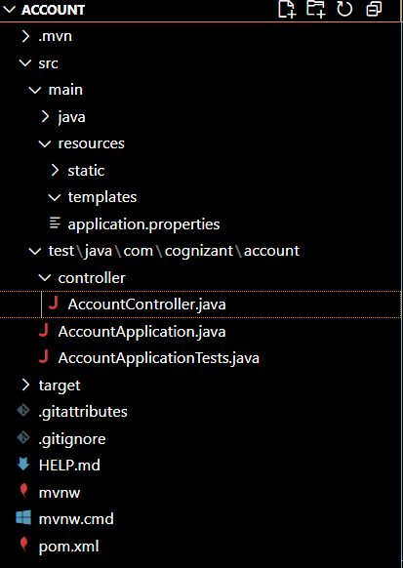

**Code:**

**AccountController.java:**package com.cognizant.account.controller;

import org.springframework.web.bind.annotation.GetMapping;

import org.springframework.web.bind.annotation.PathVariable;

import org.springframework.web.bind.annotation.RestController;

import java.util.HashMap;

import java.util.Map;

@RestController

public class AccountController {

    @GetMapping("/accounts/{number}")

    public Map<String, Object> getAccountDetails(@PathVariable String number) {

        Map<String, Object> response = new HashMap<>();

        response.put("number", number);

        response.put("type", "savings");

        response.put("balance", 234343);

        return response;

    }

}

**AccountApplication.java:**package com.cognizant.account;

import org.springframework.boot.SpringApplication;

import org.springframework.boot.autoconfigure.SpringBootApplication;

@SpringBootApplication

public class AccountApplication {

    public static void main(String[] args) {

        SpringApplication.run(AccountApplication.class, args);

        System.out.println("✅ Account Service is running on port 8080...");

    }

}

**Applications.properties:**server.port=8080

spring.application.name=account-service

Run the application and search the url in the browser

Syntax: http://localhost:<port>/<endpoint>  
**My url:** <http://localhost:8080/accounts/00987987973432>

**Output:**

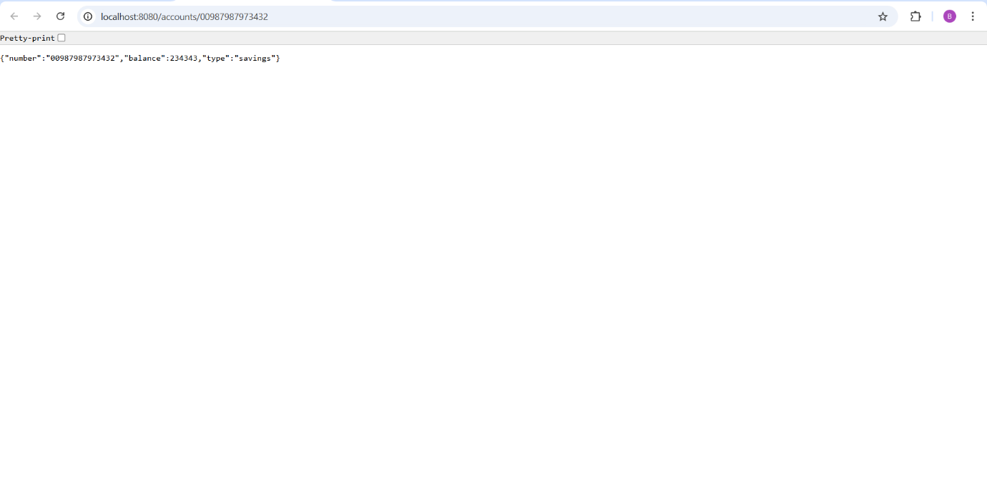

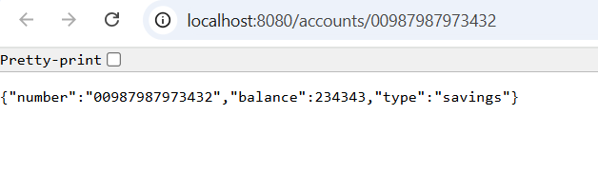

**Similarly,**

1. **For Loan:**

**Folder Structure:**

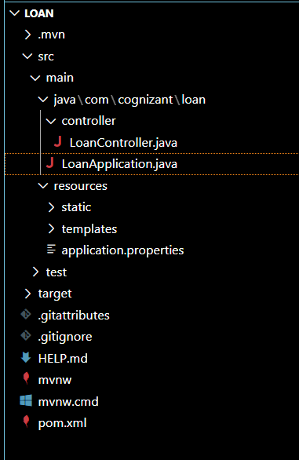

**Code:**

**LoanApplication.java:**package com.cognizant.loan;

import org.springframework.boot.SpringApplication;

import org.springframework.boot.autoconfigure.SpringBootApplication;

@SpringBootApplication

public class LoanApplication {

    public static void main(String[] args) {

        SpringApplication.run(LoanApplication.class, args);

        System.out.println(" Loan Service is running on port 8081...");

    }

}

**LoanController.java:**

package com.cognizant.loan.controller;

import org.springframework.web.bind.annotation.GetMapping;

import org.springframework.web.bind.annotation.PathVariable;

import org.springframework.web.bind.annotation.RestController;

import java.util.HashMap;

import java.util.Map;

@RestController

public class LoanController {

    @GetMapping("/loans/{number}")

    public Map<String, Object> getLoanDetails(@PathVariable String number) {

        Map<String, Object> response = new HashMap<>();

        response.put("number", number);

        response.put("type", "car");

        response.put("loan", 400000);

        response.put("emi", 3258);

        response.put("tenure", 18);

        return response;

    }

}

**application.properties:**

server.port=8081

spring.application.name=loan-service

**My url**: http://localhost:8081/loans/H00987987972342

**Output:**

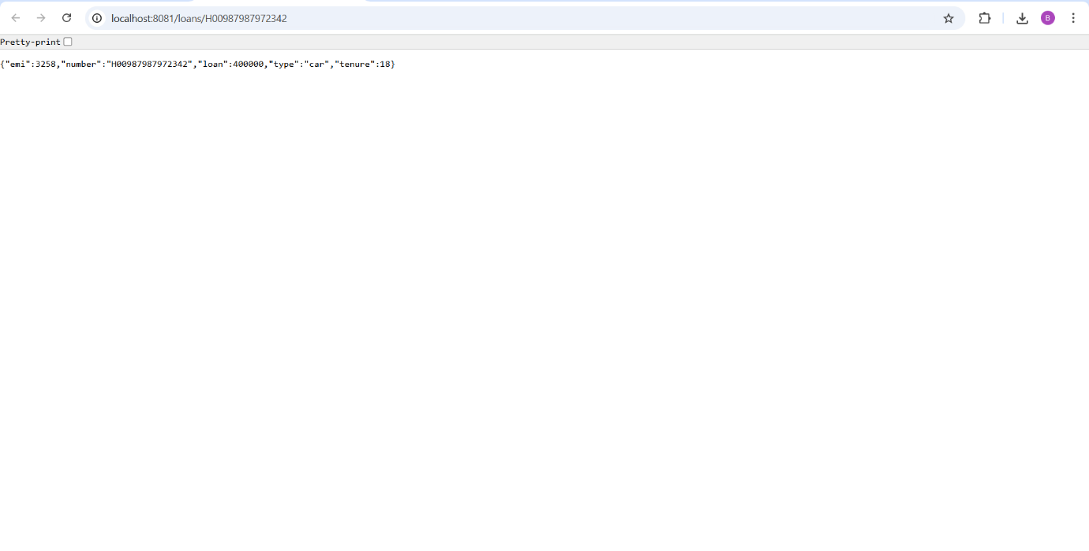

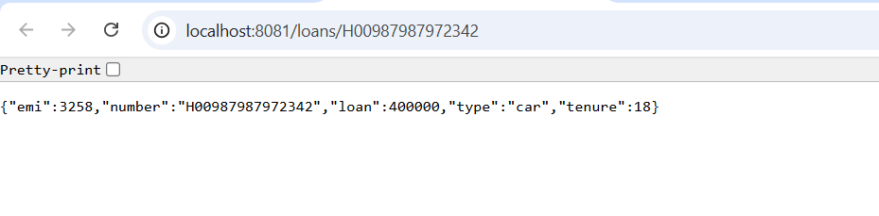

**s**